Ideation Phase
Empathize & Discover

Date | 24 September 2022
Team ID | PNT2022TMID13523
Project Name | Analytics For Hospitals Healthcare Data
Maximum Marks | 4 Marks

Empathy Map Canvas:
An empathy map is a simple, easy-to-digest visual that captures knowledge about a user’s behaviours and attitudes.

It is a useful tool to helps teams better understand their users.
Creating an effective solution requires understanding the true problem and the person who is experiencing it. The exercise of creating the map helps participants consider things from the user’s perspective along with his or her goals and challenges.
Example:
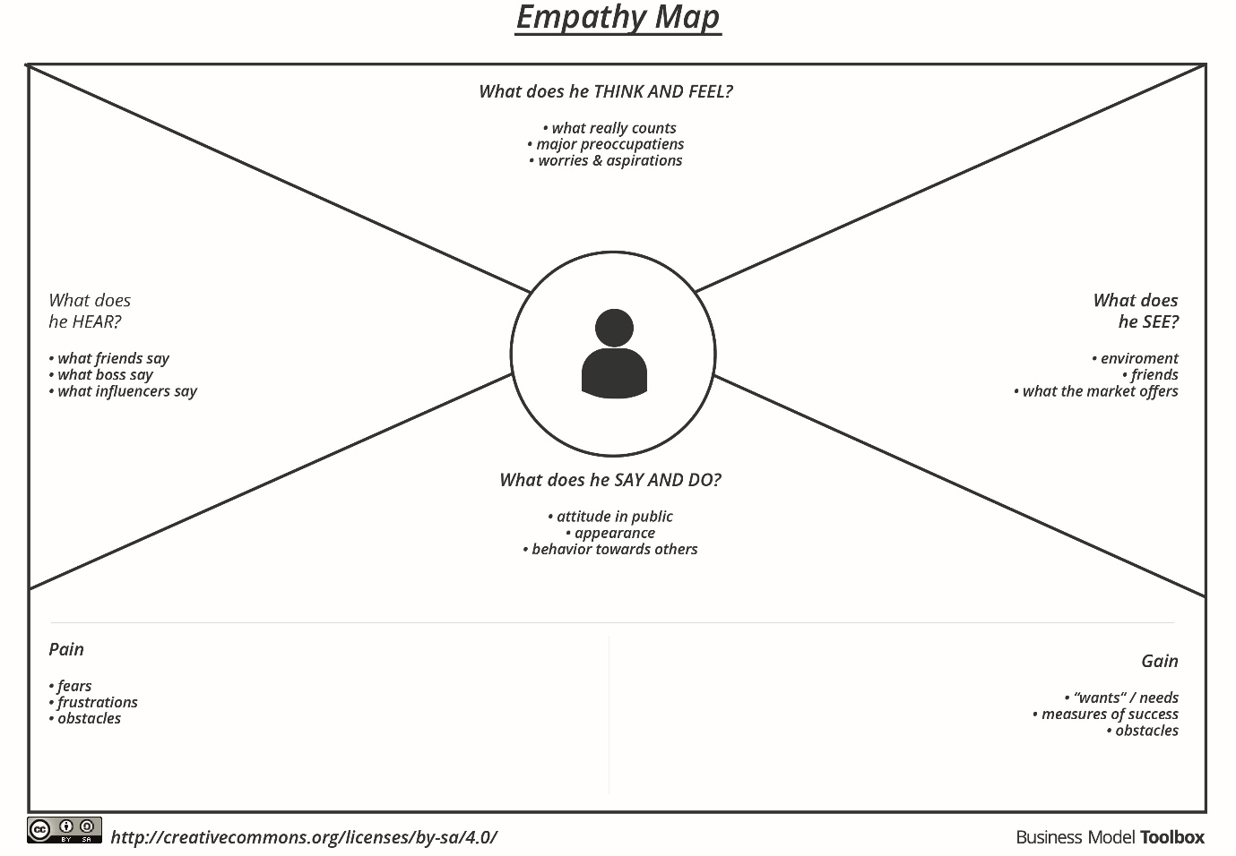

Reference: https://app.mural.co/t/thiruveni6684/m/thiruveni6684/1663828333678/ce886a6d32bcc1fc84d3b43be38c9fcd59b6a7a0?sender=uae83de0b6881a8b180d75529

Example: – Analytics For Hospitals Healthcare Data
